Task 11.1 - Manufacturing: Production Efficiency Dashboard – Monitor OEE (Overall Equipment Effectiveness),
machine downtime, and throughput.

Introduction
This project focuses on analyzing production efficiency using operational machine data. The objective of this dashboard is to monitor Overall Equipment Effectiveness (OEE), machine downtime, throughput, and efficiency performance. The dashboard helps identify performance issues, understand the impact of maintenance, and support data-driven production decisions.

Dataset Description
The dataset contains machine-level operational data collected from a production environment. Key columns used in this analysis include:
- machine_id - Unique identifier for each machine
- timestamp / date - Date and time of machine activity
- downtime - Duration of machine downtime
- maintenance_flag - Indicates whether maintenance was performed
- efficiency_score - Performance efficiency of machines
- production_status - Current operational state of machines
This data enables time-based, machine-based, and maintenance-based analysis.

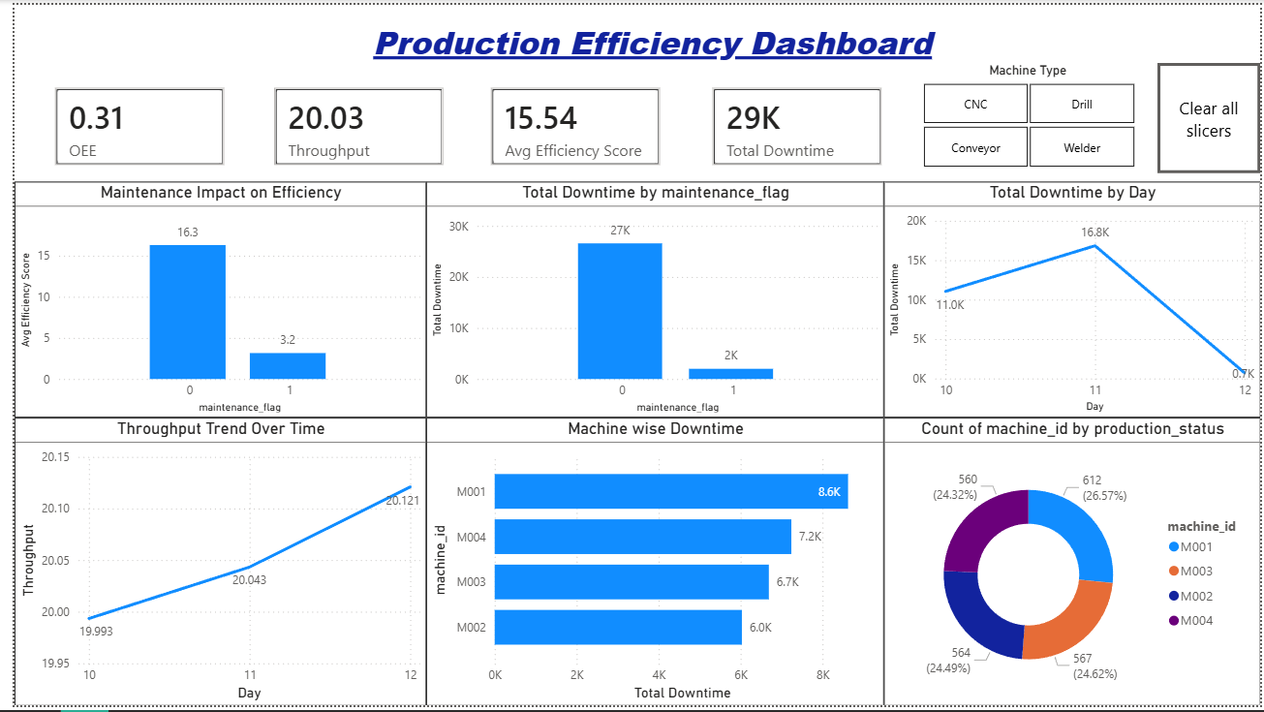

Key Performance Indicators (KPIs)
The dashboard includes four main KPIs:
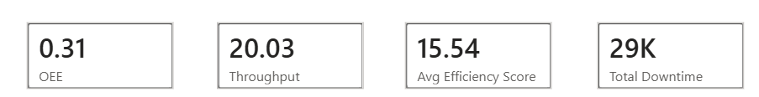
- Overall Equipment Effectiveness (OEE) - Measures how effectively machines are utilized during production.
- Throughout - Represents the average production output over time.

Total Downtime - Shows the total duration when machines were not operational.

Average Efficiency Score - Indicates the average operational efficiency of machines.
These KPIs provide a quick summary of overall production performance.

Maintenance Impact on Efficiency
This chart compares the average efficiency score between machines with and without maintenance.
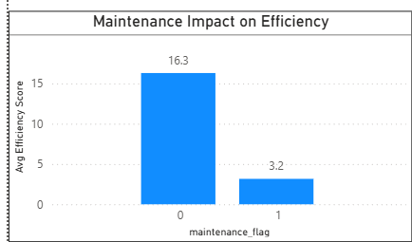
Insight - Machines that received maintenance show significantly better efficiency compared to machines without maintenance.
This highlights the importance of regular maintenance in improving machine performance.

Total Downtime by Maintenance Flag
This chart compares total downtime based on maintenance status.
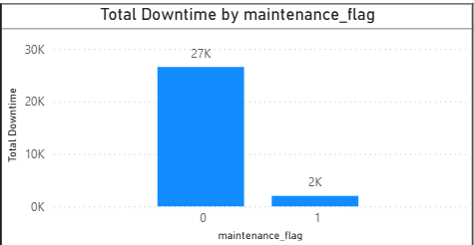
Insight - Machines without maintenance experience much higher downtime. Maintenance activities help reduce unexpected failures and production loss.

Throughput Trend Over Time
This line chart shows how throughput indicates improving production performance and operational stability.
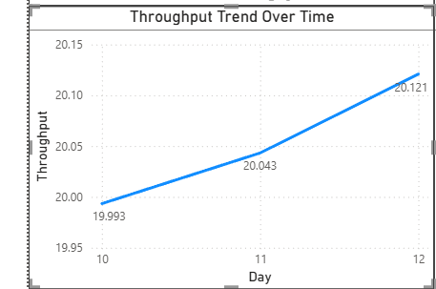
Insight - A gradual increase in throughput indicates improving production performance and operational stability.

Machine-wise Downtime Analysis
This chart shows total downtime for each machine.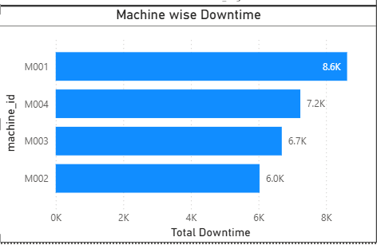
Insight - Some machines contribute more to downtime than others. These machines should be prioritized for inspection and maintenance.

Total Downtime by Day
This line chart shows how total machine downtime changes across different days.
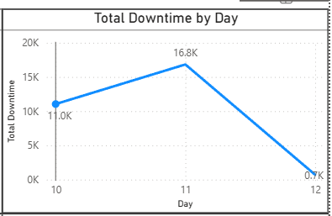
Insight - The downtime increases from Day 10 to Day 11, indicating higher machine stoppages or operational issues on that day. On Day 12, downtime drops significantly, which suggests improved machine performance, better maintenance effectiveness, or smoother production operations. This chart helps in identifying problematic days and understanding how downtime varies over time.

Count of Machine ID by Production Status
This donut chart shows the distribution of machine records across different machines.
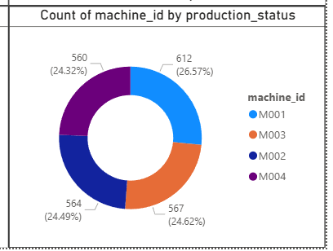
Insight - The data is evenly distributed among all machines, indicating that each machine contributes almost equally to the dataset. This confirms that the analysis is not biased toward any single machine and ensures fair comparison across machines.

Machine Type Slicer
The Machine Type slicer allows users to filter the dashboard based on specific machine categories such as CNC, Drill, Conveyor, and Welder.
By selecting a machine type, users can analyze downtime and machine distribution for only that category.

Business Insights & Conclusion
- Maintenance significantly reduces downtime and improves efficiency
- Monitoring downtime trends helps detect performance issues early
- Machine-wise analysis supports better maintenance planning
- The dashboard enables quick, data-driven production decisions
Overall, the Production Efficiency Dashboard provides a clear and actionable view of manufacturing performance.

